**1** **Introduction**

**1.1 Identification**

|  |  |  |
| --- | --- | --- |
| **Project Name** | Med Plus |  |
|  |  |
|  |  |  |
| **Document Name** | Low Level Design |  |
|  |  |
|  |  |  |
| **Document Version** | 1.0 |  |
|  |  |
| **No.** |  |  |

**2** **Design Overview**

The Business Process workflow used in our system can be broken down into three tiers: -

1. The Client Tier with the HTML and the messages that are interchanged
2. The middle tier which comprises of service mix and the Server with the business logic
3. The Back-end tier with the database.

Client Tier Middle Tier Data Management Tier

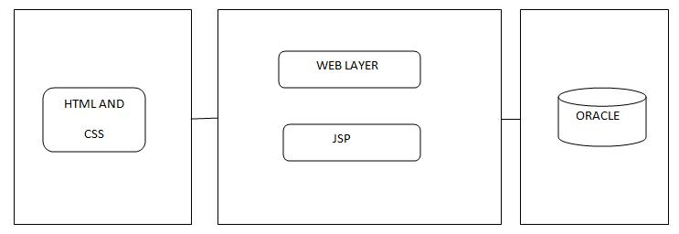

1

**3 Design Description**

**3.1 Business Process work flow**

Our scenario and workflow design call for our workflow to interface with the following hypothetical and actual components and applications:

To start with Home Page, it contains a login and signup page. While we entering into the login page, When we submitting the login page using username and password with corresponding data provided in database based on roles. It enter into four different home pages. The next is Signup page which adds new members based on their roles. The function of the Home pages are

* Role: admin

Functions: The administrator is the super user and has complete control over all the activities that can be performed. The admin can add or terminate ant members at any time. The admin can update the personal details of the below users.

* Role: User

Functions: The user can able to locate medical stores near to them. They will get remainder about the medicines when it becomes short and gets information of the medical shop which contains that medicine.

The User Interface side includes HTML and CSS.

The programming language used is Java.

The JSP is a server-side programming technology that enables dynamic, platform-independent methods for building web-based applications. The JSP component provides database access and update and change of data.

Oracle, a Relational database management system that is being used for big business due to its adaptability and practical approach to handle the data and software applications. It supports Standard Query language(SQL) to manage and manipulate data that it has. Server-side components, such as JSP in the front-end Web application with which the customer interacts.

2

The Med Plus is a simple web app, and can help manage numerous people’s medications. It also tracks your prescriptions and reminds you when it’s time for a refill. It will store all the medications

prescribed by the doctor and help maintain the stock till the time needed. The functions of the system include:

* Add or delete unlimited members
* Can locate any medical shop anywhere in the world.
* Complete details of medicines.

**3.2 Class Diagram**

It is a static structural diagram that describes the structure of a system by showing the system’s classes their attributes, operations (or methods) and the relationships among objects.

Purpose of Class Diagrams

1. Shows static structure of classifiers in a system.
2. Diagram provides a basic notation for other structure diagrams prescribed by UML.
3. Helpful for developers and other team members too.
4. Business Analysts can use class diagrams to model systems from a business perspective.

3

**3.3 Class Diagrams**

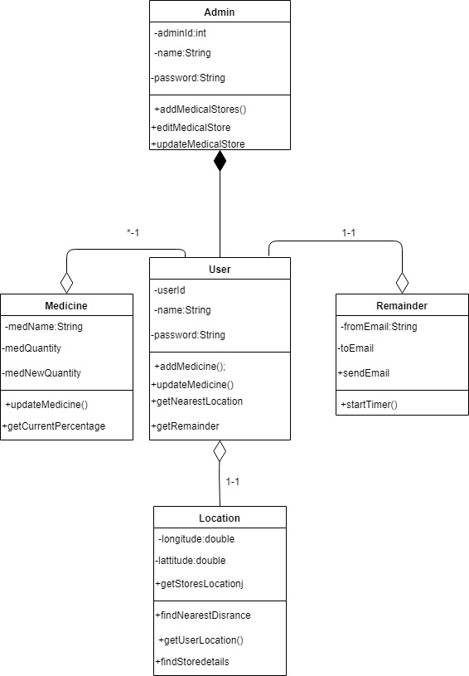

4